5. Understand what happens when duplicate IPs configured in a network.

When two devices have the same IP in a network, it causes an **IP conflict**, leading to connectivity issues. Packets can get misrouted or dropped, making both devices unstable or completely lose network access.

**Machine 1 - windows:**

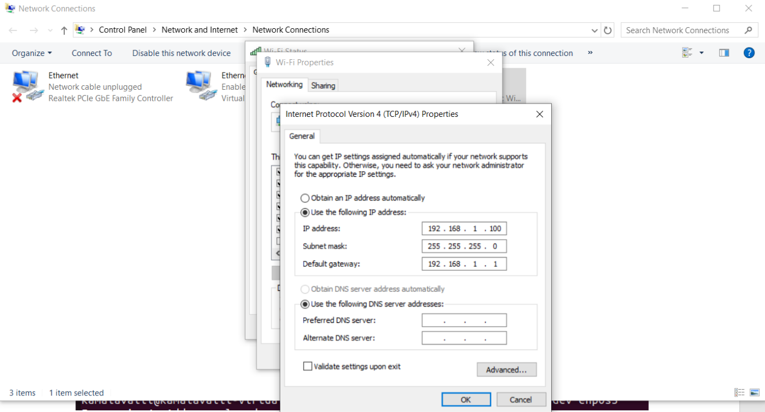

**Machine -2 Linux:**



**IP Conflict:**

**Windows**

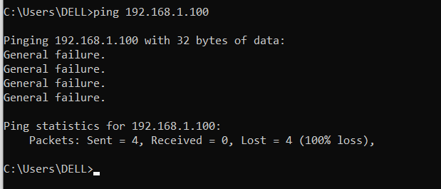

**Conflict: This caused both devices to lose network connectivity.**